MACH4METAL

metalworking machinery
Transito 21, 6909 DA Babberich, Netherlands
Tel. + 31 (0)316 – 247123
Fax. + 31 (0)316 - 247956
info@mach4metal.com
www.mach4metal.com
Bank No : 66.52.13.883
IBAN : NL33 INGB 0665 2138 83
BIC : INGBNL2A
VAT : NL 815393635B01

SCHAERER UDA 1120 turning lathe

- Make : SCHAERER Germany
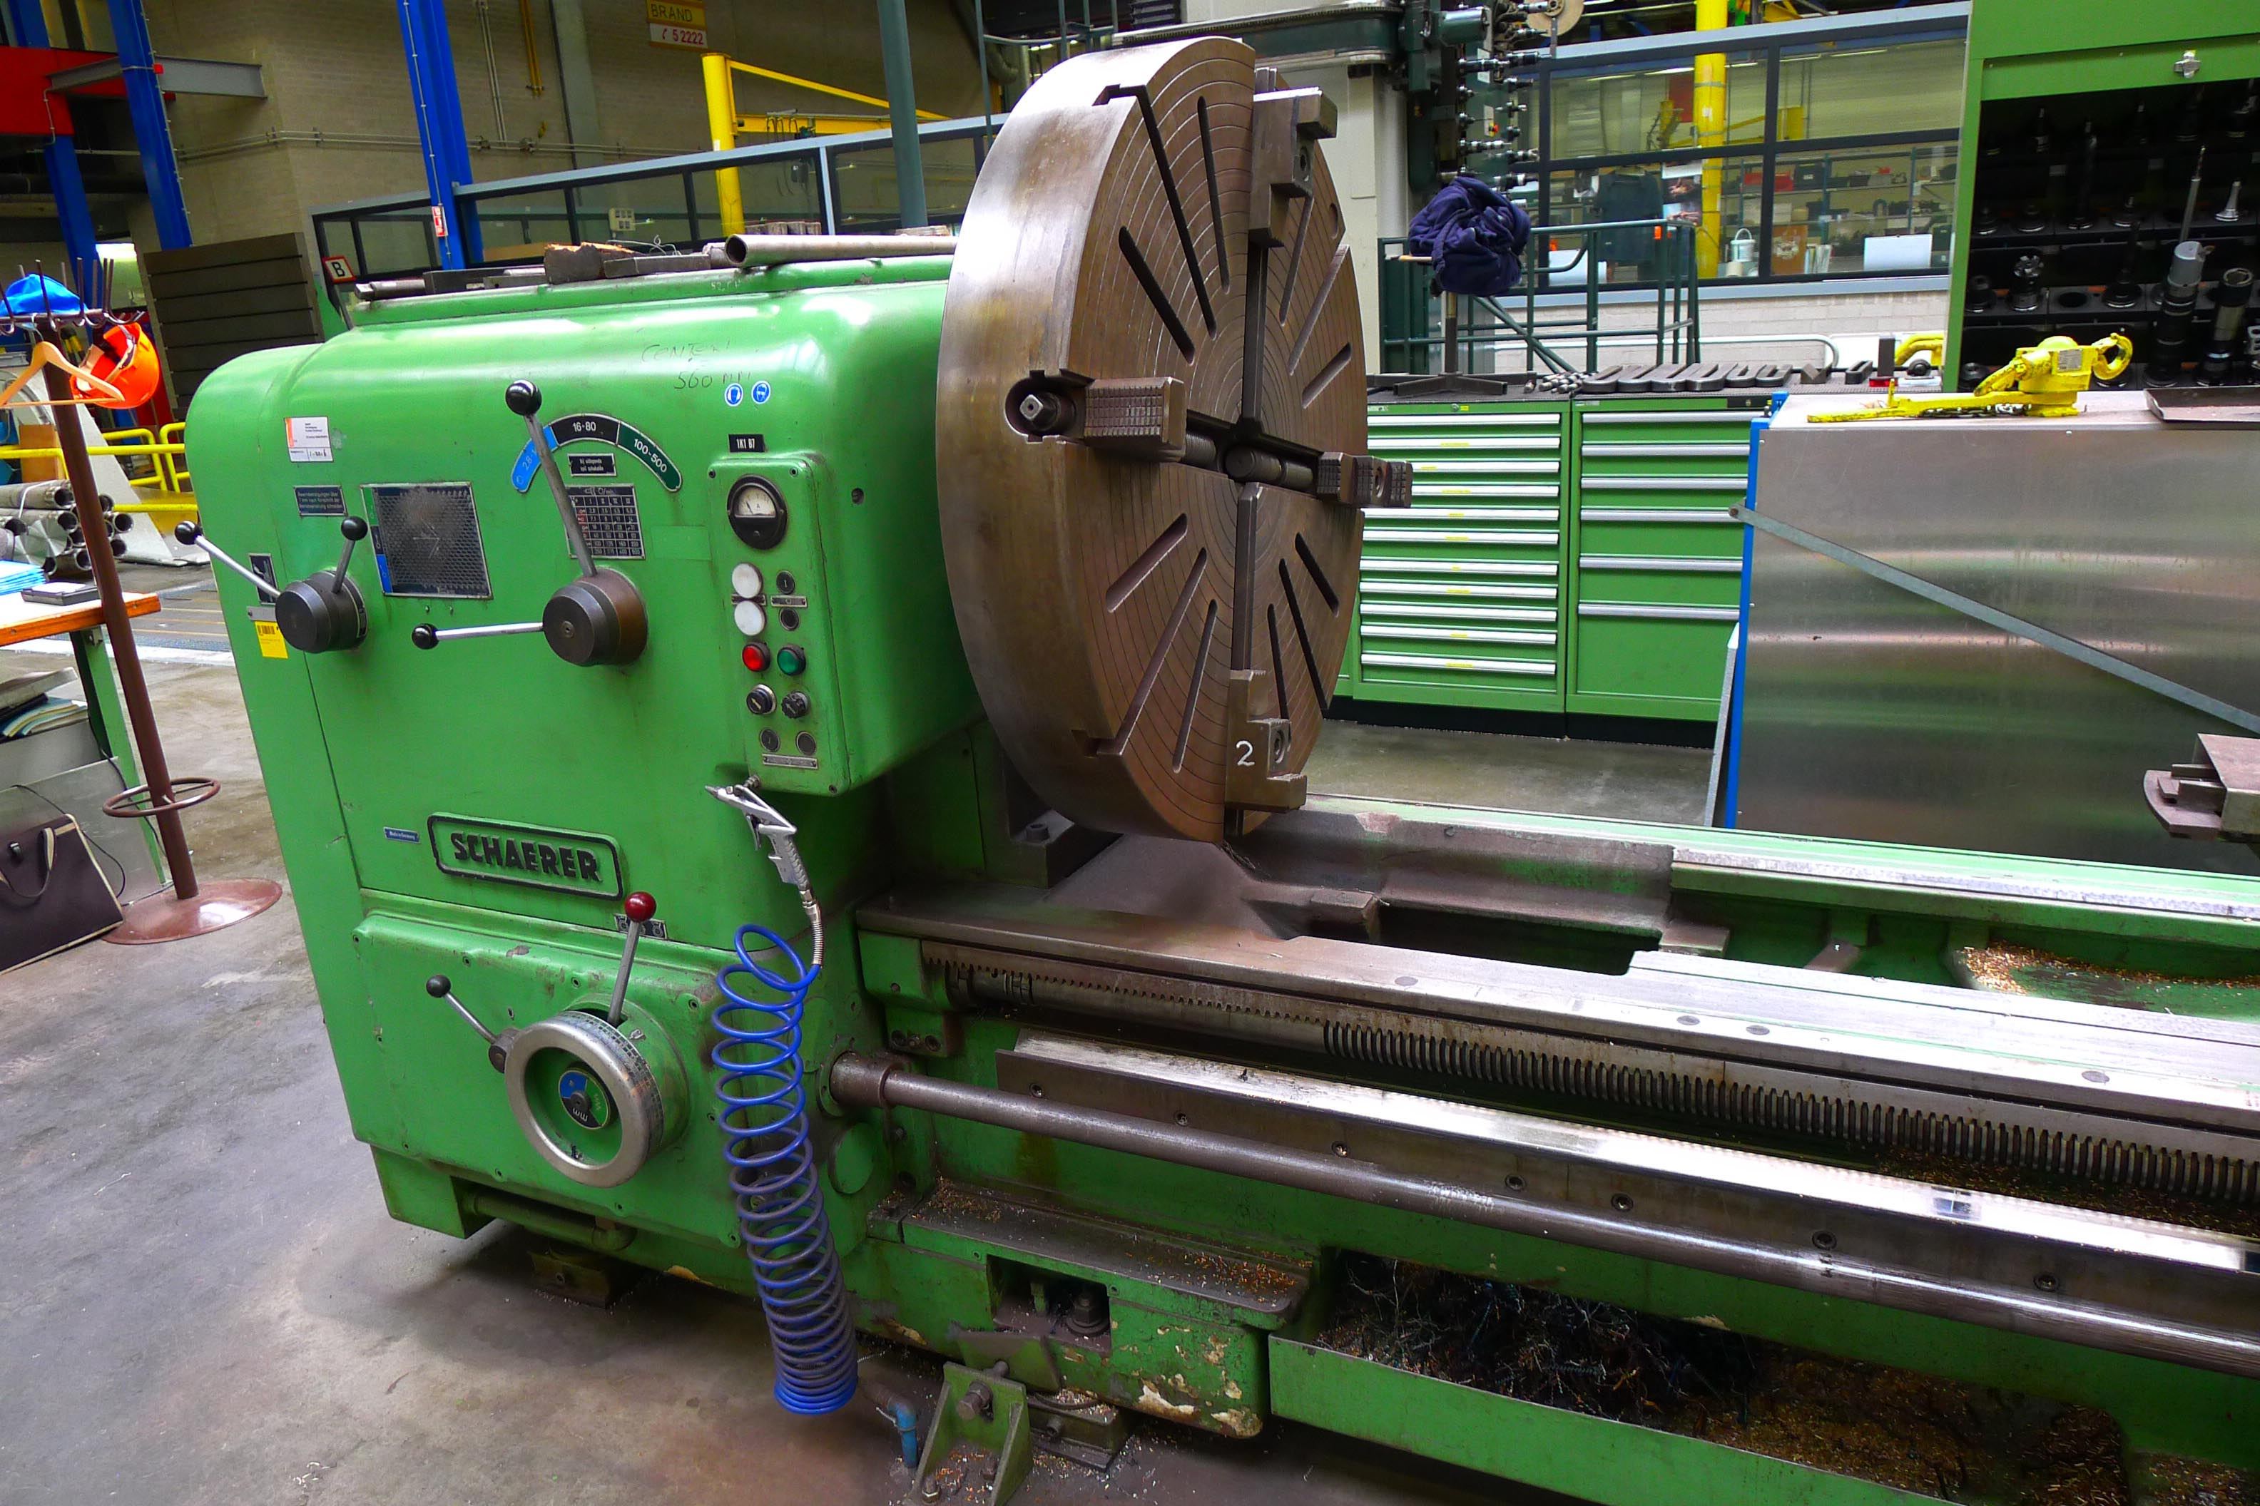
- Typ : UDA 1120
- Age : 70 er
- Mach.No : 19525

- Centre height over bed : 560
- Swing over bed : 1.120
- Swing over support :

- Centre distance : 4.000
- Centre height :
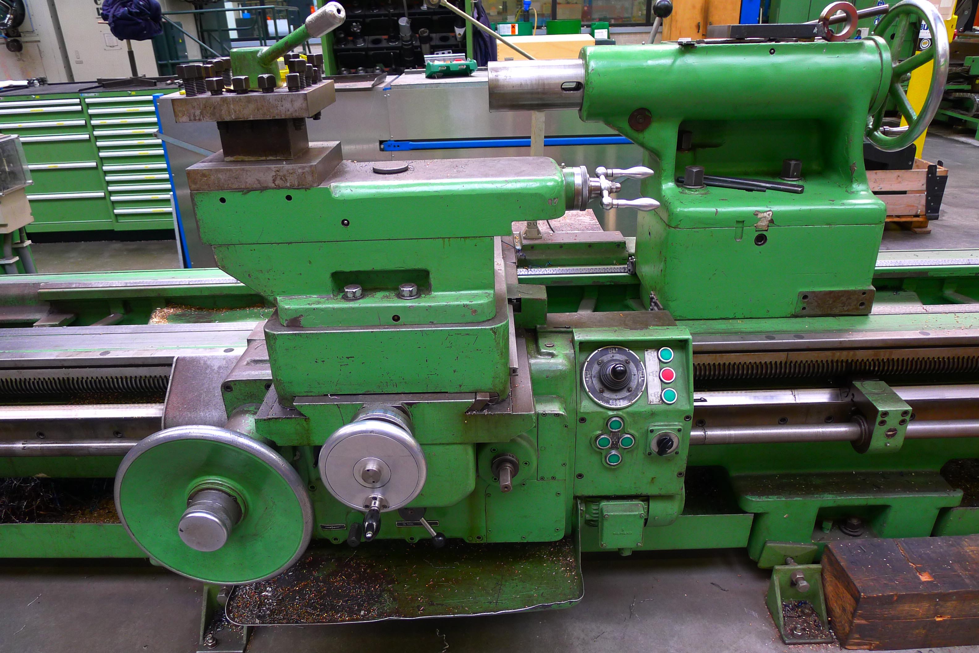

- Width off bed :
- Spindle hole :
- Tailstock quil :
- Stroke Quil and taper :

- Max. workpiece weight B. center :
- Max. workpiece in chuck 300 mm :

- Speeds 3 steps 2,8 – 14 / 16 – 80 / 100 - 500
- Power
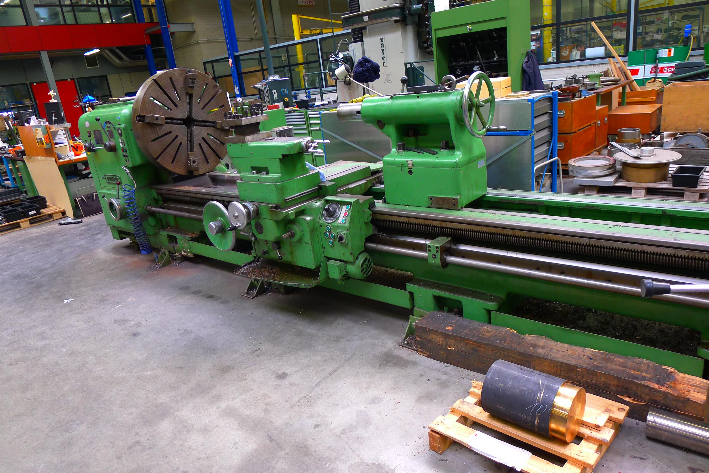
- Feeds 2 directions
- Conical turning attachmen
- 1 x 4 chuck Ø 1.000 mm
- Steady rest

- Dimensions
- Length : 6.000
- Width : 2.000
- Height : 1.600

Please Note: The above information has been obtained to the best of our ability and belief from, and from the manufacturers where possible. It is given in good faith, but its accuracy can not be guaranteed. Accordingly, it will not form a representation or constitute contractual terms. We advise you to check any vital details!

